**Assignment no : 1**

1. C programming was invented by **Dennis Ritchie**.
2. C programming was developed in the year of **1972** and at **Bell Laboratory**.
3. POP stand for **Procedure Oriented Programming**.
4. **#include<stdio.h>**

**#include<conio.h>**

**void main()**

**{**

**printf("Hello world");**

**getch();**

**}**

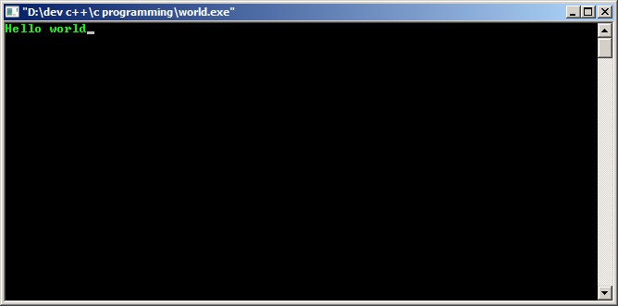

**#include<stdio.h>**

**#include<conio.h>**

**void main()**

**{**

**printf("Hello world");**

**printf("\n new line ");**

**}**

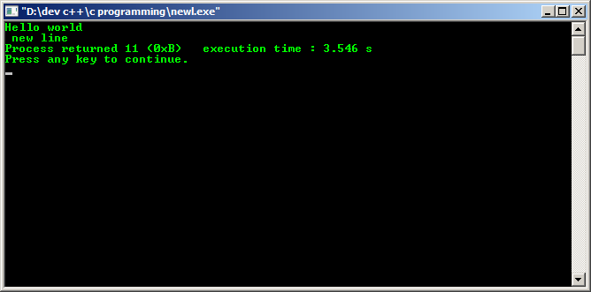

**7)**

**#include<stdio.h>**

**#include<conio.h>**

**void main()**

**{**

**int a;**

**printf("enter something :");**

**scanf("%d ", &a);**

**printf("you entered : %d",a);**

**}**

